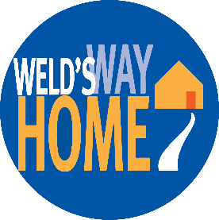

Preventing and ending homelessness
Households are attaining and maintaining stable housing

Your investment to United Way of Weld County provides services for people like Omar.

Omar stayed at United Way’s Housing Navigation Center cold weather shelter and kept meeting with staff after it closed in April. He worked hard with his Housing Coordinator to become document ready, which for most guests is the first step to getting back into housing. With staff advocacy and support, Omar participated in the new City of Greeley Homeless2Housing program, regaining housing a few weeks later. With the fundamental need of permanent housing met, Omar is now becoming more stable overall, and is reconnecting with family and friends.

