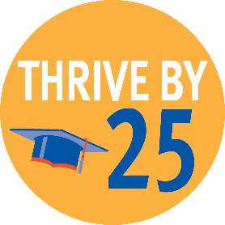
Connecting youth to caring adults
Youth are graduating high school and transitioning to a successful adulthood by age 25

Your investment to United Way of Weld County provides services for youth in Weld County.

A recurring theme for Weld County Recreation Scholarship Program participants is that the support is being requested by grandparents caring for their grandchildren. For instance, a grandmother on a limited income in Fort Lupton recently took over guardianship of her two grandchildren. Grandma was desperate to find a summer program. The local recreation program provided scholarships for both of the children. As a result, their summer days were filled with swimming, crafts, rock climbing, gym games, going on field trips and making friends!

