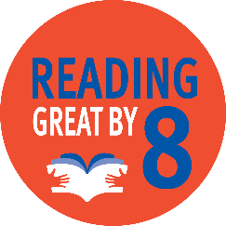
Building the foundation for early childhood success
Children are entering Kindergarten ready and reading at Grade level by the start of 4th Grade

Your investment to United Way of Weld County provides services for families and children throughout Weld County.

For two years, a child care center in Erie sought a State of Colorado child care provider license. Many difficulties were experienced, including a church location that needed facility improvements. The director was not deterred, being motivated by the dire need for more child care in the Carbon Valley. With United Way staff, the director better navigated the licensing process, successfully applied for grants and became a Universal Preschool Colorado provider. Licensed in March 2023, they are now caring for seven children and seeking additional enrollments.

