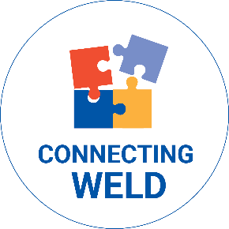

Linking people to the help that they need
Human services are increasing in visibility, accessibility and capacity

Your investment to United Way of Weld County provides services for people like Josephine.

Josephine had a lot of expenses thrown at her all at once, which overwhelmed her and made her fall behind on the electricity bill. Being an older adult on a fixed income without family support, Josephine didn’t have many options. She called 211 Colorado and was connected to help. First off, she received $100 from a Greeley church, which helped Josephine catch up with current expenses. Her 211 Colorado Resource Navigator also helped her sign up for the statewide Low-income Energy Assistance Program (LEAP) and looked into food assistance resources. As a result of her call to 211 Colorado, Josephine is thankful and back on track.

