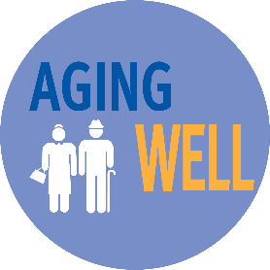

Helping older adults age well in our community
Older adults are living full and productive lives

Your investment to United Way of Weld County provides services for people like Ken.

At 82, Ken was still able to live on his own. One day while crossing the street, his foot caught a sharp, high curb and he fell. Nine months later, he was still recovering. Stories like Ken’s are at the heart of the Aging Well community-wide initiative. It is founded on the idea that an age-friendly community is better for everyone. For instance, more curb cuts not only make it safer for Ken to get around, it also helps people in wheelchairs, children riding their bikes, adults with disabilities and mothers pushing strollers.

