It’s LOCAL! Give Where You Live!

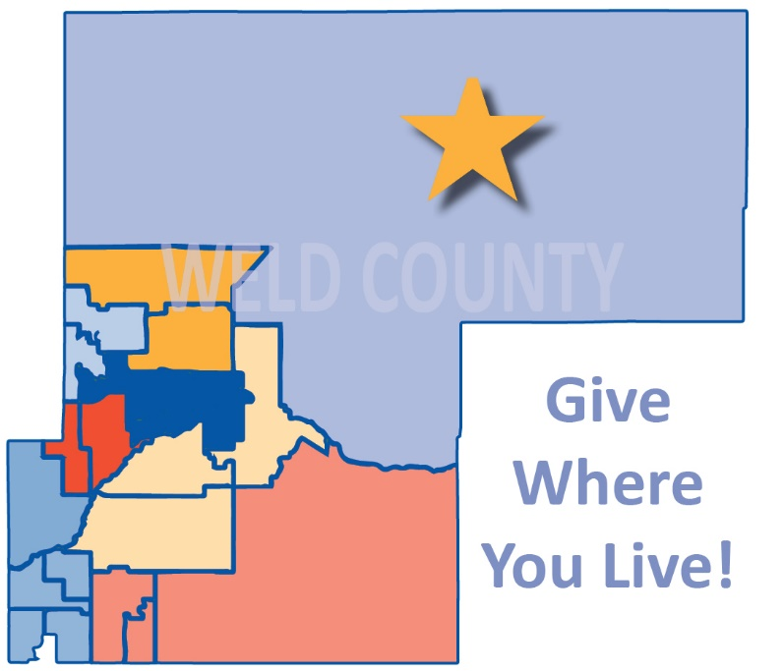

Our United Way Campaign is in full swing. Have you committed yet? If not, it is important to know that your donation…
- Stays Local – What is raised in Weld County stays in Weld County. The stories, relationships and successes that you hear about are all local. (If you work in another county and live in Weld County, be sure to designate United Way of Weld County on your pledge or donation form.)
- Goes Directly to the Work – With cash and in-kind donations, Cornerstone Partners generously provide foundational support for United Way’s work. This means that your donation is used only for assisting our more vulnerable Weld County neighbors.

When you donate to United Way, you are helping a friend, a neighbor, or even a family member. Your support creates a better Weld County for us all! [link for giving page]

